Assignment-3

Student Name | Ridham Verma
Student Roll Number | SSNCE195002091

1.Create a Bucket in IBM object storage.
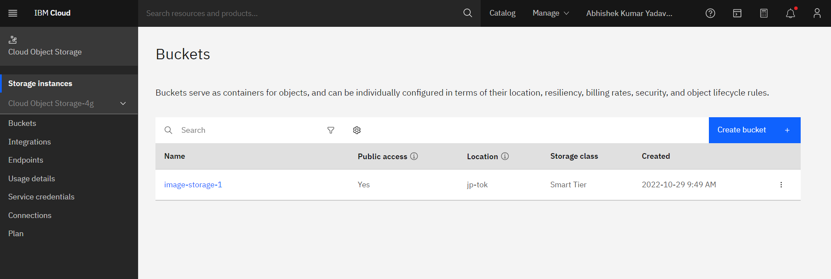
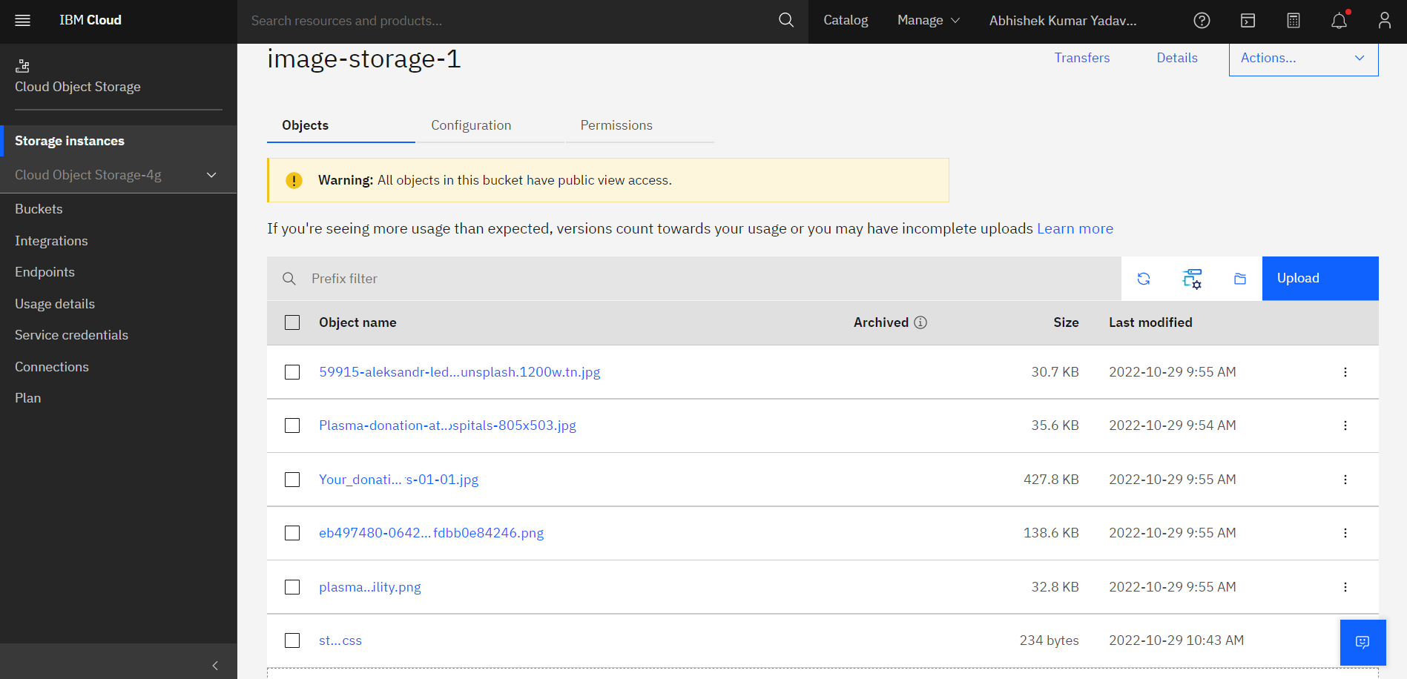

2.Upload an 5 images to ibm object storage and make it public. write html code to displaying all the 5 images.
Source code:
<!DOCTYPE html>
<html lang="en">
<head>
<meta charset="UTF-8">
<meta http-equiv="X-UA-Compatible" content="IE=edge">
<meta name="viewport" content="width=device-width, initial-scale=1.0">
<title>IBM Cloud Storage</title>
<link rel="stylesheet" href="style.css">
</head>
<body>
<center>
<h1>Assignment 3</h1>
<img src="https://image-storage-1.s3.jp-tok.cloud-object-storage.appdomain.cloud/eb497480-0642-11eb-9aa3-ffdbb0e84246.png" alt="img1">
<img src="https://image-storage-1.s3.jp-tok.cloud-object-storage.appdomain.cloud/Plasma-donation-at-Wockhardt-Hospitals-805x503.jpg" alt="img2">
<br>
<img src="https://image-storage-1.s3.jp-tok.cloud-object-storage.appdomain.cloud/Your_donation_matters-01-01.jpg" alt="img3">
<img src="https://image-storage-1.s3.jp-tok.cloud-object-storage.appdomain.cloud/plasma-eligibility.png" alt="img4">
<br>
<img src="https://image-storage-1.s3.jp-tok.cloud-object-storage.appdomain.cloud/59915-aleksandr-ledogorov-310150-unsplash.1200w.tn.jpg" alt="img5">
</center>
</body>
</html>

3.Upload a CSS page to the object storage and use the same page in your HTML code.
Source code:
<!DOCTYPE html>
<html lang="en">
<head>
<meta charset="UTF-8">
<meta http-equiv="X-UA-Compatible" content="IE=edge">
<meta name="viewport" content="width=device-width, initial-scale=1.0">
<title>IBM Cloud Storage</title>
<link rel="stylesheet" href="https://image-storage-1.s3.jp-tok.cloud-object-storage.appdomain.cloud/style.css">

</head>
<body>
<center>
<h1>Assignment 3</h1>
<img src="https://image-storage-1.s3.jp-tok.cloud-object-storage.appdomain.cloud/eb497480-0642-11eb-9aa3-ffdbb0e84246.png" alt="img1">
<img src="https://image-storage-1.s3.jp-tok.cloud-object-storage.appdomain.cloud/Plasma-donation-at-Wockhardt-Hospitals-805x503.jpg" alt="img2">
<br>
<img src="https://image-storage-1.s3.jp-tok.cloud-object-storage.appdomain.cloud/Your_donation_matters-01-01.jpg" alt="img3">
<img src="https://image-storage-1.s3.jp-tok.cloud-object-storage.appdomain.cloud/plasma-eligibility.png" alt="img4">
<br>
<img src="https://image-storage-1.s3.jp-tok.cloud-object-storage.appdomain.cloud/59915-aleksandr-ledogorov-310150-unsplash.1200w.tn.jpg" alt="img5">
</center>
</body>
</html>
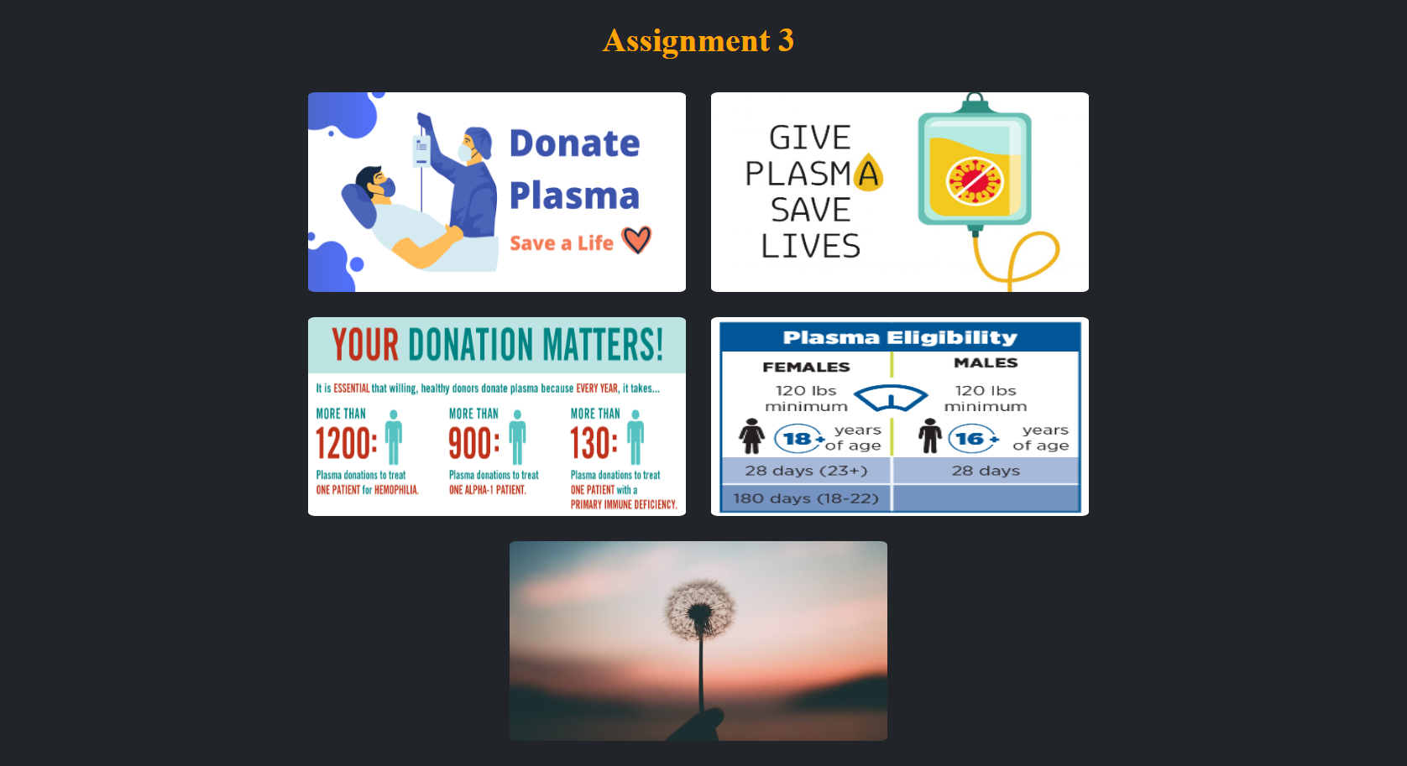

4.Design a chatbot using IBM Watson assistant for hospital. Ex: User comes with query to know the branches for that hospital in your city. Submit the web URL of that chat bot as a assignment.
ChatBot Link :

https://web-chat.global.assistant.watson.appdomain.cloud/preview.html?backgroundImageURL=https%3A%2F%2Fjp-tok.assistant.watson.cloud.ibm.com%2Fpublic%2Fimages%2Fupx-5010b7ba-39dd-427a-b7b5-afee90f53458%3A%3Aa836fb52-d0fa-4d44-98be-ceaa9b2d8704&integrationID=66576f0c-5408-4edc-803b-d9de1f553e8b&region=eu-gb&serviceInstanceID=2607efc7-375b-465c-9e61-399a0f694519

5.Create Watson assistant service with 10 steps and use 3 conditions in it. Load that script in HTML page.
Source code:
<!DOCTYPE html>
<html lang="en">
<head>
<meta charset="UTF-8">
<meta http-equiv="X-UA-Compatible" content="IE=edge">
<meta name="viewport" content="width=device-width, initial-scale=1.0">
<title>IBM Cloud Storage</title>
<link rel="stylesheet" href="https://image-storage-1.s3.jp-tok.cloud-object-storage.appdomain.cloud/style.css">
<script>
window.watsonAssistantChatOptions = {
integrationID: "66576f0c-5408-4edc-803b-d9de1f553e8b", // The ID of this integration.
region: "eu-gb", // The region your integration is hosted in.
serviceInstanceID: "2607efc7-375b-465c-9e61-399a0f694519", // The ID of your service instance.
onLoad: function(instance) { instance.render(); }
};
setTimeout(function(){
const t=document.createElement('script');
t.src="https://web-chat.global.assistant.watson.appdomain.cloud/versions/" + (window.watsonAssistantChatOptions.clientVersion || 'latest') + "/WatsonAssistantChatEntry.js";
document.head.appendChild(t);
});
</script>
</head>
<body>
<center>
<h1>Assignment 3</h1>
<img src="https://image-storage-1.s3.jp-tok.cloud-object-storage.appdomain.cloud/eb497480-0642-11eb-9aa3-ffdbb0e84246.png" alt="img1">
<img src="https://image-storage-1.s3.jp-tok.cloud-object-storage.appdomain.cloud/Plasma-donation-at-Wockhardt-Hospitals-805x503.jpg" alt="img2">
<br>
<img src="https://image-storage-1.s3.jp-tok.cloud-object-storage.appdomain.cloud/Your_donation_matters-01-01.jpg" alt="img3">
<img src="https://image-storage-1.s3.jp-tok.cloud-object-storage.appdomain.cloud/plasma-eligibility.png" alt="img4">
<br>
<img src="https://image-storage-1.s3.jp-tok.cloud-object-storage.appdomain.cloud/59915-aleksandr-ledogorov-310150-unsplash.1200w.tn.jpg" alt="img5">
</center>
</body>
</html>

